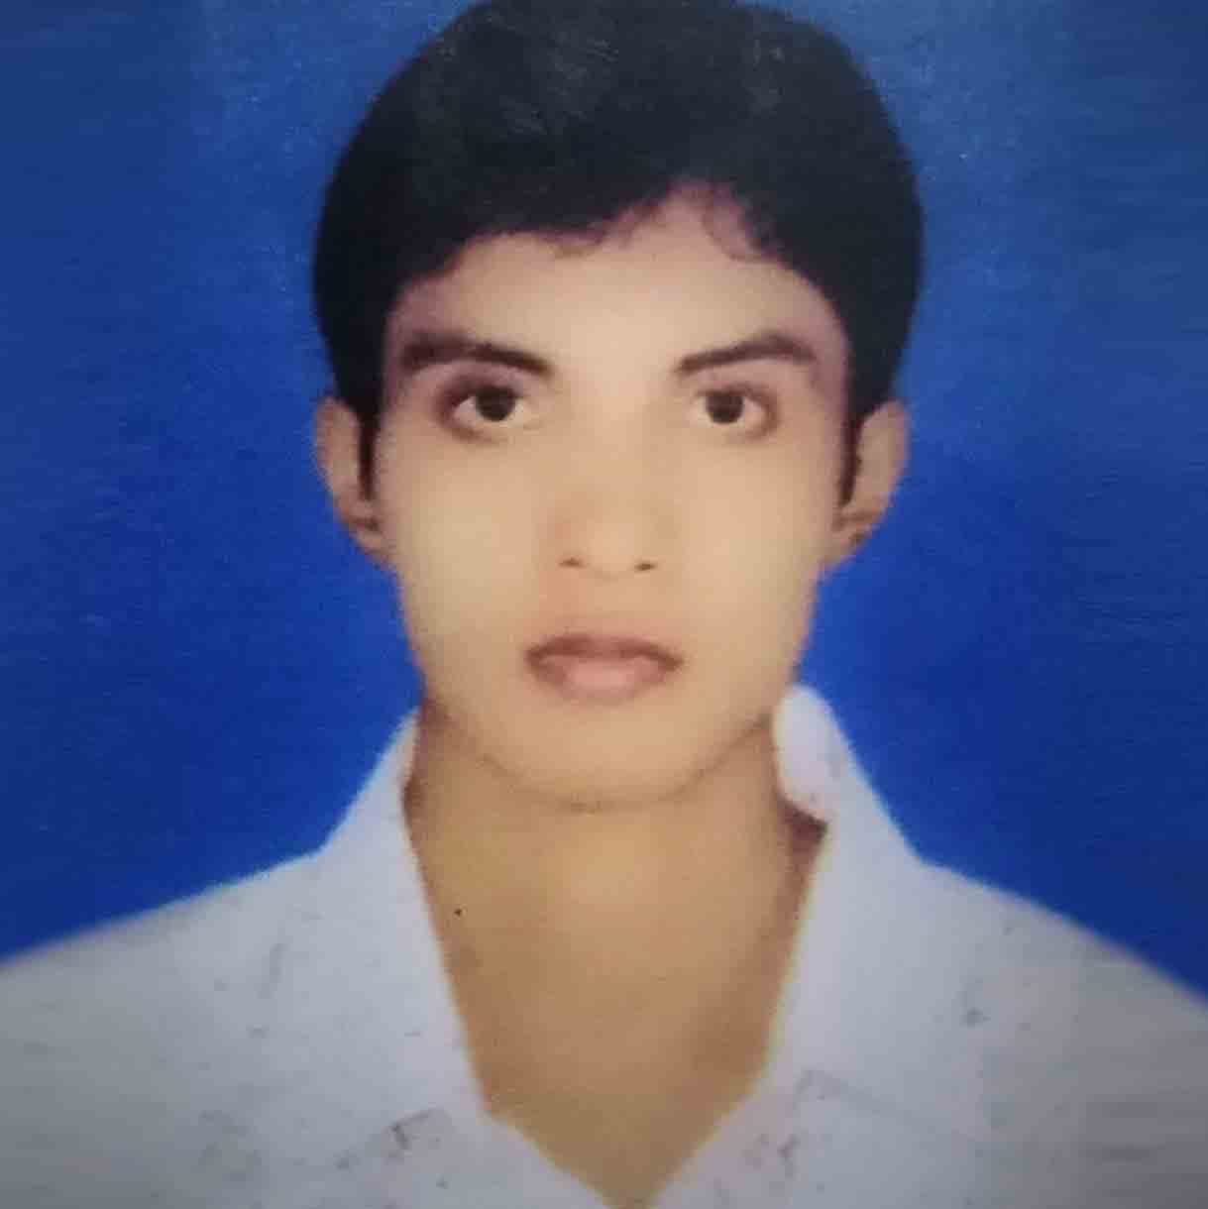
Md. Humayun Kabir (Ripon).
CONTACT  Address:  Bamonsur, Ati Bazar, Keranigonj, Dhaka. 1312  Mobile:  +8801717-429073  +8801617-429073  Email:  h.ripon1989@gmail.com. |  | CAREER OBJECTIVES  Creates challenging and conductive environment. Able to achieve a very responsive and rewarding career where my qualification and capabilities are further enhanced and developed.  CAREER SUMMARY  I have experience in Data Entry, Marketing, Branding, Operation & Development Sector. Also completed the Professional Customer Service Course under BACCO & have experience this Sector.  WORK EXPERIENCE  Total Year of Experience: 3 years 3 months.  07/2019 – 02/2020  Company: FIFO Tech. Worked As: Data-Entry Operator (Night Shift). Location: Software Technology Park, Janata Tower, 9th Floor, Kawran Bazar,  Dhaka.  Duties & Responsibilities: Data Analysis & Operate.  01/2019 – 06/2019  Company: PTi System, Worked As: Business Development Officer. Location: 57/G (2nd Floor), Kawran Bazar (Opposite of Northern University),  Dhaka. Duties & Responsibilities: Sales & Promotion.  08/2014 – 02/2015  Company: Okapia-Mobile BD Ltd. Worked As: Brand Promoter (BP).  Location: Chowrasta, Gazipur, Dhaka.  Duties & Responsibilities: Okapia Mobile Brand Development.  03/2013 – 07/2014  Company: Apollo Computer Worked As: Marketing Executive.  Location: Konabari , Gazipur  Duties & Responsibilities: Apollo Computer Marketing & Promotion.  EDUCATION  MBA From State University of Bangladesh (SUB).  Major in Human Resource Management (HRM).  CGPA-2.58 (out of 4.00), Passing Year 2015.  BBA Hon`s From MIST. (National University).  Major in Marketing.  CGPA-2.80 (Out of 4.00), Passing Year 2012.  HSC From Abdur Rashid Talukder Degree College, Dashmina.  Commerce Group.  CGPA-4.40 (out of 5.00), Barishal Board, Passing Year 2008.  SSC From Dashmina High School.  Science Group.  CGPA-3.38 (out of 5.00), Barishal Board, Passing Year 2006.  TRAINING SUMMARY  SEIP Project Course Under BACCO  PCS (Professional Customer Service) From FIFO TECH  (50 Class 200 hours in 2019).  - Customer Service, BPO Service, Office Management, Basic IT Support.  - Team Environment, Occupational Health & Safety (OHS).  Communicative English Language Speaking From WSDA (Workplace Skill Development Academy)  (5 Class 20 hours in 2019).  - Fluency in English.  Computer Course  MS Office Expert Program From Osan Computer (3 Months in 2011).  - MS Excel, Power-Point, MS Word.  ADDITIONAL SKILLS  Microsoft Office, Excel, PowerPoint (Expert Program), Hardware Tabulation. Graphics Design (Logo, Visiting Card, Banner, Billboard & Others), Web Development & SEO. Internet Browsing & Video Studio (Video Editing).  LANGUAGE PROFICIENCY  Bangla & English  Excellent in both spoken & Written.  PERSONAL DETAILS  Father’s Name: Talukder Abdul Barique.  Mother’s Name: Saleha Begum  Permanent Address: Vill: Dashmina, P.O.: Dashmina, P.S: Dashmina,  Dist.: Patuakhali.  Date of birth: 06/07/1990  Religion: Islam  Blood Group: O(+)  National ID No: 9140573081  REFERENCES  Name: Professor Md. Shirajul Mollah. Name: Engr. Md. Golam Sarwar.  Organization: DUET Organization: Head,CSE,MIST.  Designation: Professor of mathematics’. Designation: Professor of CSE.  Address: DUET, Gazipur-1700. Address: DUET, Gazipur-1700.  Mobile No: +8801715-091879 Mobile No: +8801911-936214  Email: mollah123@yahoo.com Email: csesarwar@gmail.com  Relation: Academic Relation: Academic

